1 Record all Dockerfiles
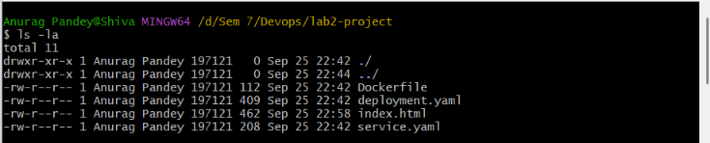
2. Docker Build Successful
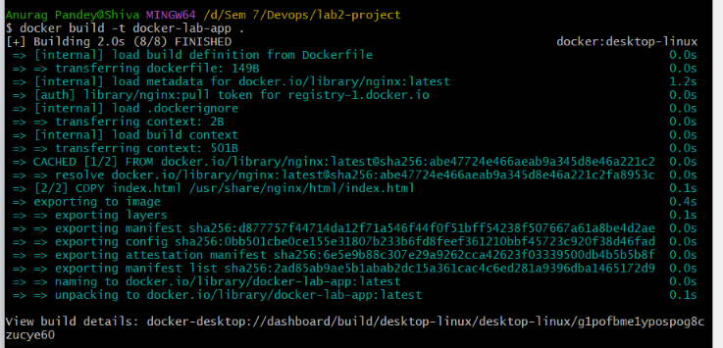
3 Docker Container Running (docker ps)
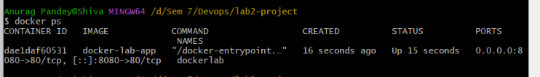
4. Application Running on localhost:8080
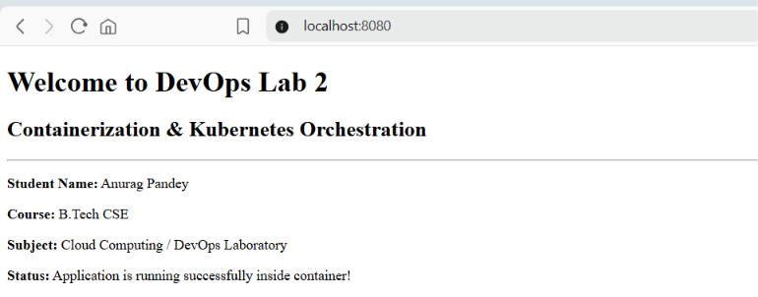
5. Minikube Started Successfully
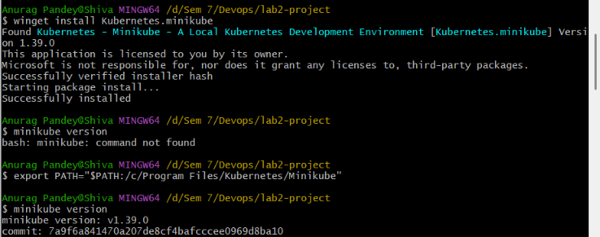
6. Screenshots & Verification Register
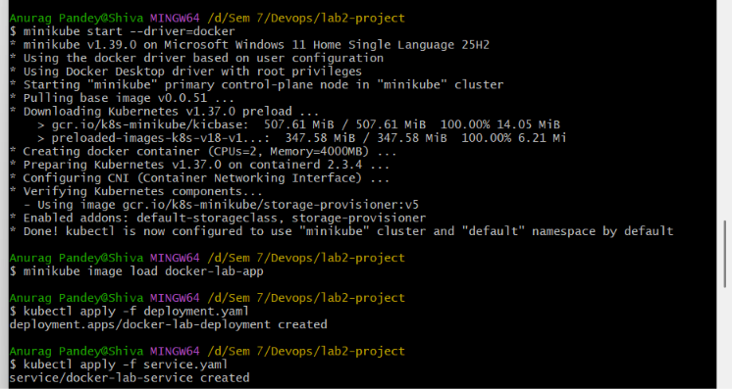
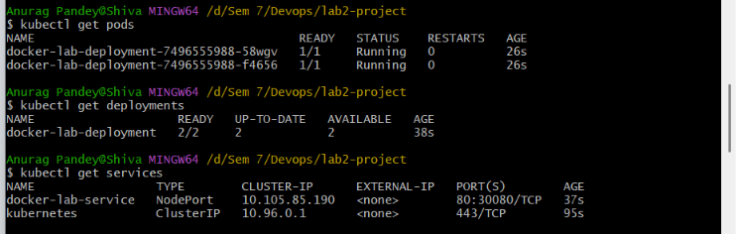
7. Application Opened Through Kubernetes Service
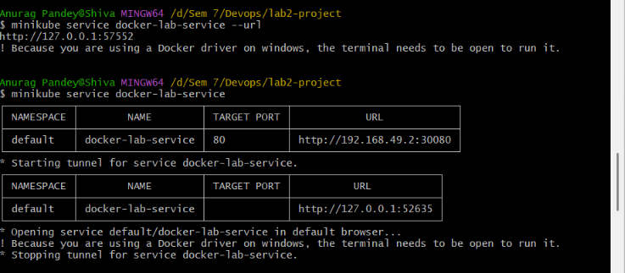
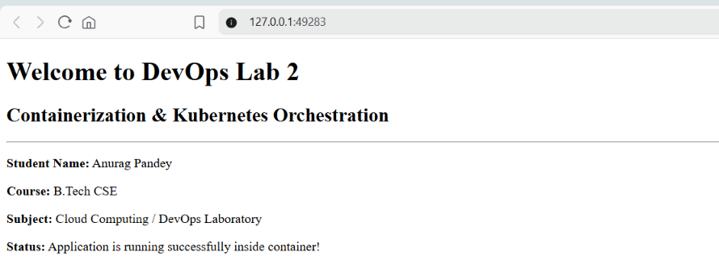
8.Scaling to 4 Pods
